**How to Install Bash on Windows 10**

RELATED ARTICLE

[**What’s New in Windows 10’s Anniversary Update**](https://www.howtogeek.com/248177/whats-new-in-windows-10s-anniversary-update/)

To get started, ensure you’ve installed the Windows 10 Anniversary Update. This only works on 64-bit builds of Windows 10, so it’s time to [switch to the 64-bit version of Windows 10](https://www.howtogeek.com/228042/how-to-switch-from-32-bit-windows-10-to-64-bit-windows-10/) if you’re still using the 32-bit version.

Once you’re sure you’re using the correct version of Windows 10, open the Settings app and head to Update & Security > For Developers. Activate the “Developer Mode” switch here to enable Developer Mode.

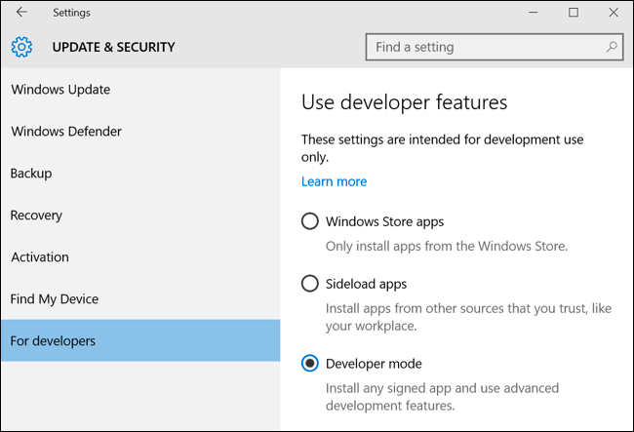

Next, open the Control Panel, click “Programs,” and click “Turn Windows Features On or Off” under Programs and Features. Enable the “Windows Subsystem for Linux (Beta)” option in the list here and click “OK.”

After you do, you’ll be prompted to reboot your computer. Click “Restart Now” to reboot your computer and Windows 10 will install the new feature.

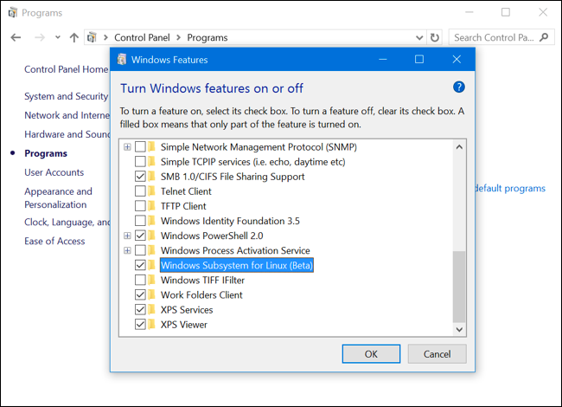

After your computer restarts, click the Start button (or press the Windows key), type “bash”, and press “Enter.”

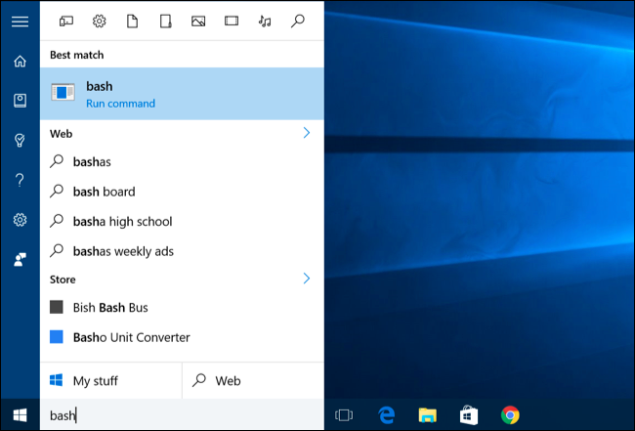

The first time you run the bash.exe file, you’ll be prompted to accept the terms of service. The command will then download the “Bash on Ubuntu on Windows” application from the Windows Store. You’ll be asked to create a user account and password for use in the Bash environment.

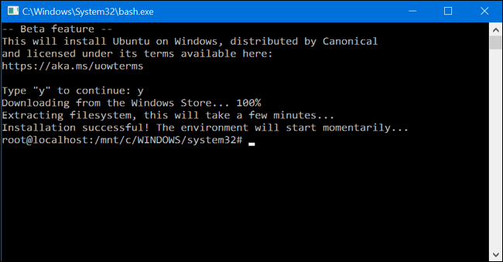

If you’d like to automate the installation of Bash instead, you can run the following command in a Command Prompt window. This will automatically agree to all prompts and set the default user to “root” with no password:

lxrun /install /y

**How to Use Ubuntu’s Bash Shell and Install Linux Software**

You’ll now have a full command-line bash shell based on Ubuntu. Because they’re the same binaries, you can use Ubuntu’s apt-get command to install software from Ubuntu’s repositories. You’ll have access to all the Linux command line software out there, although not every application may work perfectly–especially in the initial beta releases.

To open the Bash shell, just open your Start menu and search for “bash” or “Ubuntu.” You’ll see a “Bash on Ubuntu on Windows” application. You can pin this application shortcut to your Start menu, taskbar, or desktop for easier access.

NB. $ sudo apt-get install build-essential

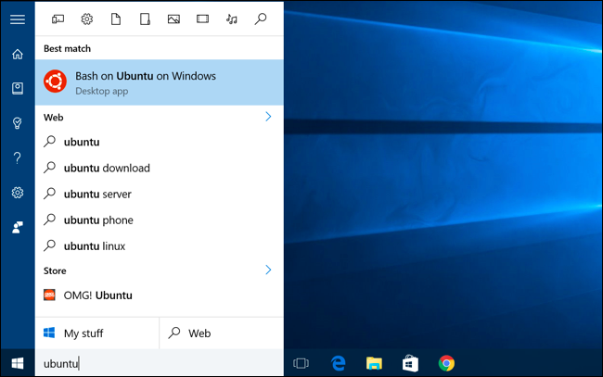

If you’re experienced using a Bash shell on Linux, Mac OS X, or other platforms, you’ll be right at home. You don’t need to use [sudo](https://www.howtogeek.com/111479/htg-explains-whats-the-difference-between-sudo-su/), as you’re given a root shell. The “root” user on UNIX platforms has  full system access, like the “Administrator” user on Windows. Your Windows file system is located at /mnt/c in the Bash shell environment.

Use the same Linux terminal commands you’d use to get around. If you’re used to the standard Windows Command Prompt with its DOS commands, here are a few basic commands on both Bash and Windows:

* Change Directory: **cd** in Bash, **cd** or **chdir** in DOS
* List Contents of Directory: **ls** in Bash, **dir** in DOS
* Move or Rename a File: **mv** in Bash, **move** and **rename** in DOS
* Copy a File: **cp** in Bash, **copy** in DOS
* Delete a File: **rm** in Bash, **del** or **erase** in DOS
* Create a Directory: **mkdir** in Bash, **mkdir** in DOS
* Use a Text Editor: **vi** or **nano** in Bash, **edit** in DOS

RELATED ARTICLE

**[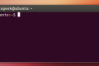](https://www.howtogeek.com/140679/beginner-geek-how-to-start-using-the-linux-terminal/)**

[**Beginner Geek: How to Start Using the Linux Terminal**](https://www.howtogeek.com/140679/beginner-geek-how-to-start-using-the-linux-terminal/)

It’s important to remember that, unlike Windows, the Bash shell and its Linux-imitating environment are case-sensitive. In other words, “File.txt” with a capital letter is different from “file.txt” without a capital.

For more instructions, consult [our beginner’s guide to the Linux command-line](https://www.howtogeek.com/140679/beginner-geek-how-to-start-using-the-linux-terminal/) and other similar introductions to the Bash shell, Ubuntu command line, and Linux terminal online.

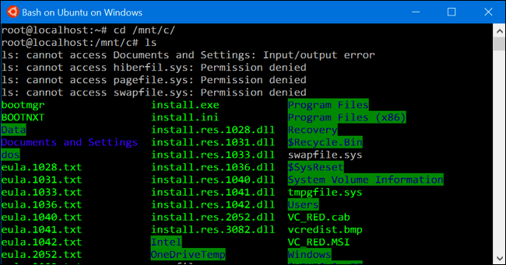

You’ll need to [use the apt-get command](https://www.howtogeek.com/63997/how-to-install-programs-in-ubuntu-in-the-command-line/) to install and update the Ubuntu environment’s software. Be sure to prefix these commands with “sudo”, which makes them run as root–the Linux equivalent of Administrator. Here are the apt-get commands you’ll need to know:

* Download Updated Information About Available Packages: **sudo apt-get update**
* Install an Application Package: **sudo apt-get install packagename** (Replace “packagename” with the package’s name.)
* Uninstall an Application Package: **sudo apt-get remove packagename** (Replace “packagename” with the package’s name.)
* Search for Available Packages: **sudo apt-cache search word** (Replace “word” with a word you want to search package names and descriptions for.)
* Download and Install the Latest Versions of Your Installed Packages: **sudo apt-get upgrade**

Once you’ve downloaded and installed an application, you can type its name at the prompt and press Enter to run it. Check that particular application’s documentation for more details.

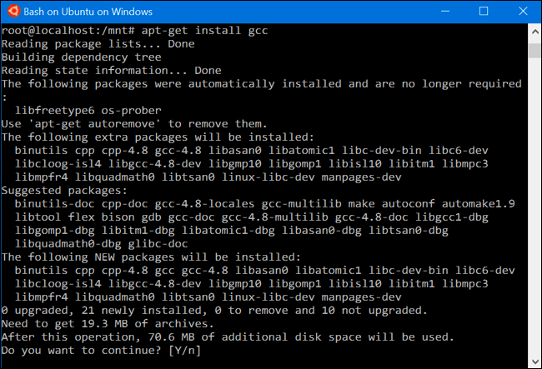

**Bonus: Install the Ubuntu Font for a True Ubuntu Experience**

If you want a more accurate Ubuntu experience on Windows 10, you can also install the Ubuntu fonts and enable them in the terminal.

Download the [Ubuntu Font Family](http://font.ubuntu.com/) from Ubuntu’s website. Open the downloaded .zip file and locate the “UbuntuMono-R.ttf” file. This is the Ubuntu monospace font, which is the only one used in the terminal. It’s the only font you need to install.

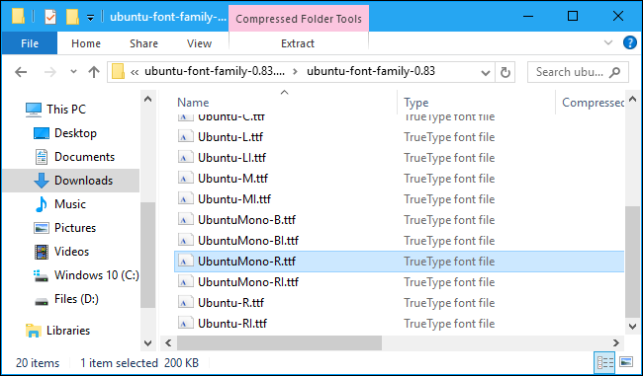

Double-click the “UbuntuMono-R.ttf” file and you’ll see a preview of the font. Click “Install” to install it on your system.

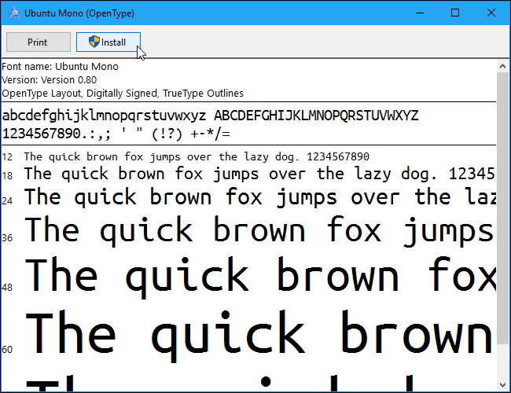

RELATED ARTICLE

**[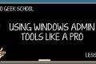](https://www.howtogeek.com/school/using-windows-admin-tools-like-a-pro/lesson5/)**

[**Learning to Use the Registry Editor Like a Pro**](https://www.howtogeek.com/school/using-windows-admin-tools-like-a-pro/lesson5/)

To make the Ubuntu monospace font become an option in the console, you’ll need to add a setting to [the Windows registry](https://www.howtogeek.com/school/using-windows-admin-tools-like-a-pro/lesson5/).

Open a registry editor by pressing Windows+R on your keyboard, typing regedit , and pressing Enter. Navigate to the following key:

HKEY_LOCAL_MACHINE\SOFTWARE\Microsoft\Windows NT\CurrentVersion\Console\TrueTypeFont

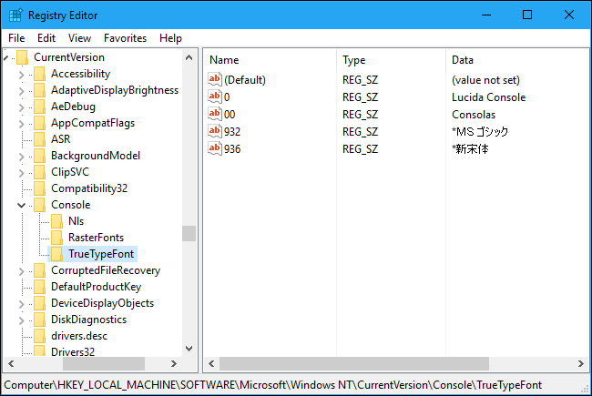

Right-click in the right pane and select New > String Value. Name it 000 .

Double-click the “000” string you just created and enter Ubuntu Mono as its value data.

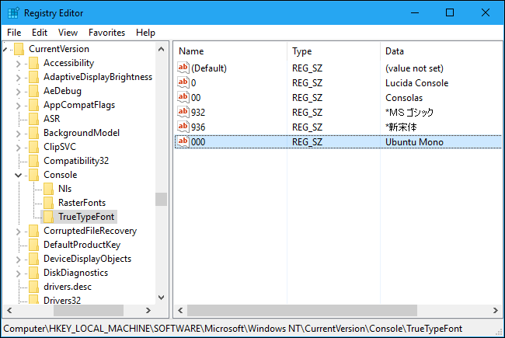

Launch a Bash window, right-click the titlebar, and select “Properties”. Click the “Font” tab and select “Ubuntu Mono” in the font list.

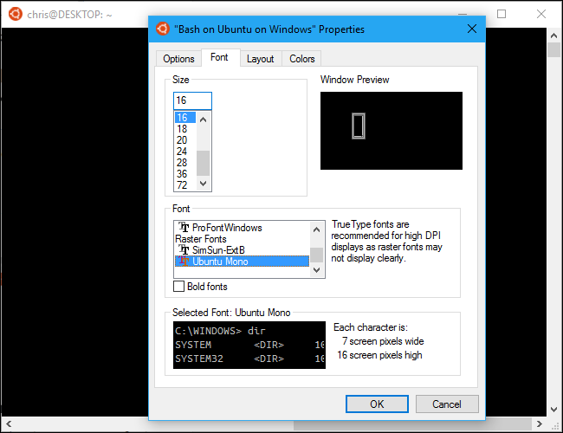

Remember, software you install in the Bash shell is restricted to the Bash shell. You can’t access it from the Command Prompt, PowerShell, or elsewhere in Windows. Software in the Bash shell also can’t interact directly with or launch Windows programs, although the Bash environment and Windows have access to the same files on your computer.

However, you can create Bash shell scripts (.sh scripts) and run them with the Bash shell.